Scenario

*A child has been kidnapped….*



*When the kidnappers called in on the ransom demand, the child's mother, Esperanza, thinks that she heard the child’s (Maria Estrella) voice in the background. The police are not sure - they need assurance that the voice heard in the background of the kidnapper’s ransom recording is actually Maria Estrella’s before dropping off the ransom demand and coordinating FBI’s hostage rescue team.*

*Compare the two voice sound files using the methodology below and determine if the sound files match.*

Project Objectives:

1. Write algorithms for basic signal recognition comparisons
2. Convert math/power functions into computer algorithms/code
3. Explore physical influences and behavior of acoustics

A speech signal is an acoustical signal that can be concerted into an electrical signal with a microphone. The electrical signal can then be converted into a series of numbers that represent the amplitudes of the electrical signal values. These numbers can be stored in data files so that the speech signal can be analyzed using computer programs. Suppose that we are interested in analyzing speech signals for the words, "zero", "one", "two",..., "nine". The goal of this analysis would be to develop ways of identifying the correct digit from a data file containing the utterance of an unknown digit.

The figure below contains a plot of an utterance of the digit "zero". The analysis of a complicated signal often starts with computing some statistical measurement that we will discuss in class.

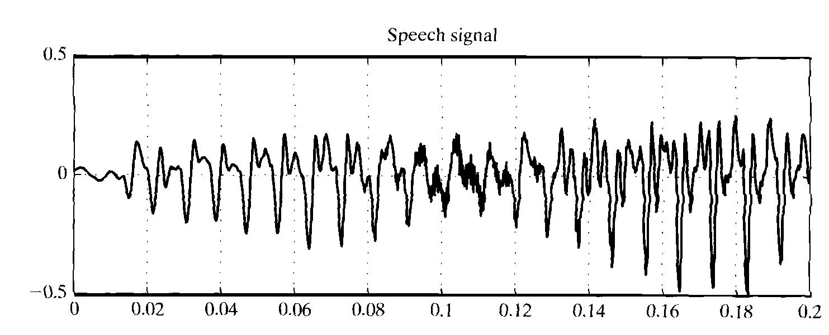

Other measurements used with speech signals include the average magnitude, or average absolute value, which is computed as shown in the equation (a) where n is the number of data values.

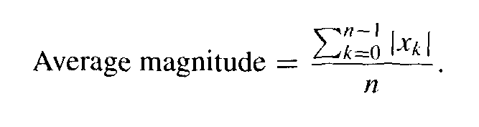 Equation (a)

Another metric used in speech analysis is the average power of the signal, which is the average squared value, as shown in equation (b).

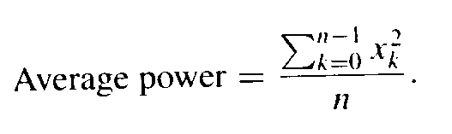Equation (b)

The number of zero crossings in a speech signal is also a useful statistical measurement. This value is the number of times that the speech signal transitions from a negative to a positive value, or from a positive value to a negative value. Transition from a nonzero value to a zero value is not a zero crossing.

Write a program to read a speech signal from a data file named "two_a.txt". This file contains values that represent Maria Estrella’s utterance of the word "two". Each line of the file contains a single value representing a measurement from the microphone taken in time increments of 0.0002 seconds. So 5,000 measurements represent one second of data. The data file contains only valid data, with no header or trailer line; a maximum of 5,000 values is contained in the file. Compute and print the following statistical measurements from the file:

(a) Mean (use function named “mean” )

(b) Standard Deviation (use function named “stdDev” )

(c) Variance (use function named “var” )

(d) Average power (use function named “avgPower” )

(e) Average magnitude (use function named “avgMagnitude” )

(f) Number of zero crossings (use function named “zeroCross” )

Use a separate function for each of the statistical measurements. Global values are not allowed in this project. Perform the same calculations for the data file "two_b.txt". The “two_b.txt” file was recorded from the kidnapper ransom message.

List the results in a table, in file "comparison.txt". Create a table listing the

values for each data file, and the % difference , similar to:

|  |
| --- |
| Team members:...  two_a.txt two_b.txt % difference  Mean  Standard  Etc... |

In addition to correctly writing the program described above, please answer the following questions:

1. Create a table of the values calculated from the two data files.
2. Which values for each data file match most closely?
3. Which values for each data file are most different?
4. Are there other statistical measures that you could suggest?
5. Can you determine if these sound recordings are from the same person? Explain.

Place these answers in the driver file, in program comments